**Unit 3 Guided Practice: Wireless Network**

**Task 1 – Build your network**

In packet tracer, you will open the following network. This network contains a wireless SOHO router connected to a DSL modem to the Internet. The Internet is also connected to an Internet Server back at your home office.

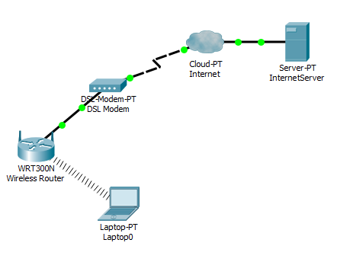

Add the following devices to your network and make sure they connect into the wireless system.

2 – Tablet PC

2 – Smartphone

1 – WirelessEndDevice

Go to one of your devices and open a web browser from the desktop

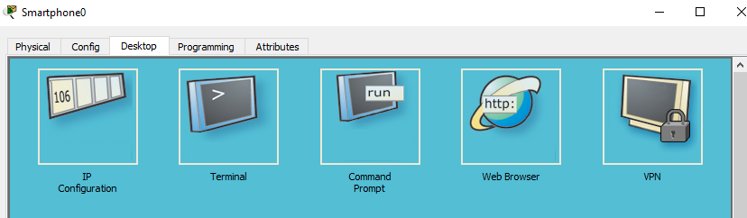

Type the web address of server.com into the URL box on the browser.

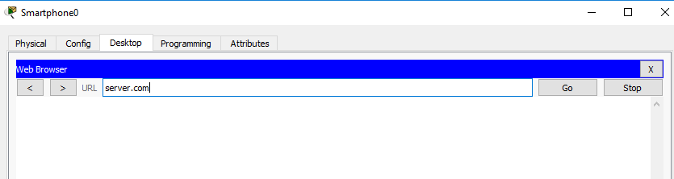

Verify that you can reach the Internet server. Take a screenshot

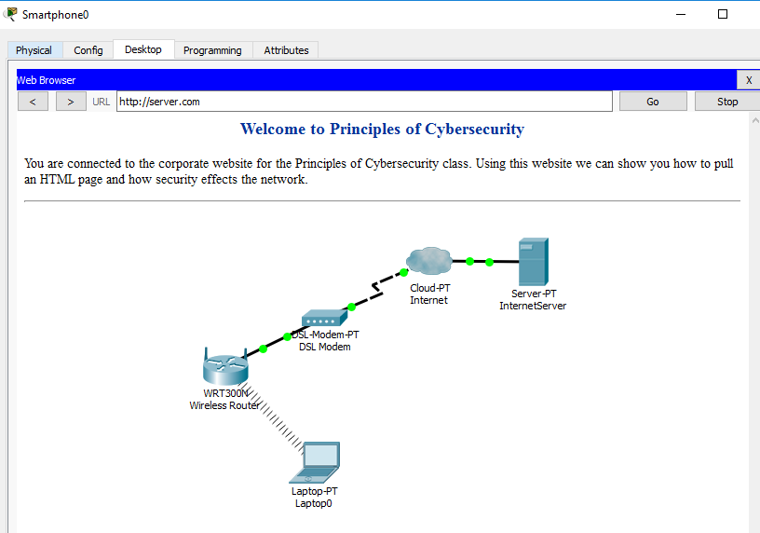

Go into your wireless router, click on GUI and go to the status window.

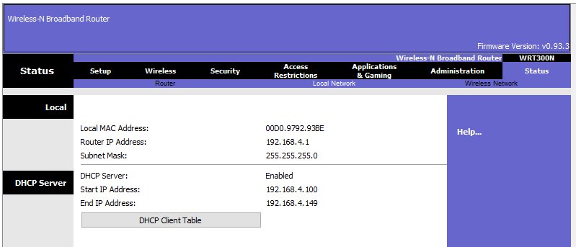

Click on the DHCP client table. How many devices does your network show?

Click on the wireless tab and then wireless security

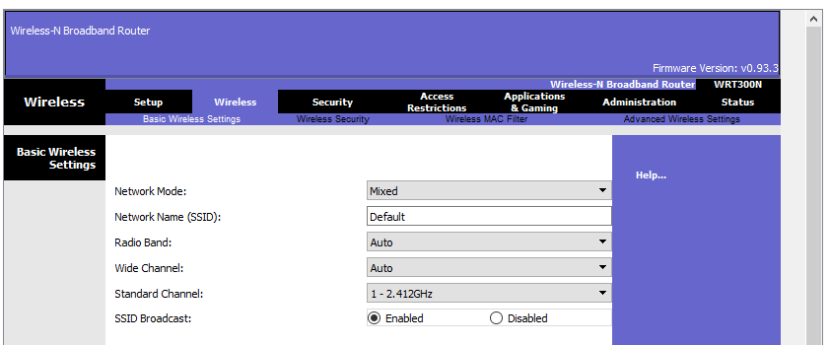

What type of wireless security does your router have by default?

Click on the drop down menu and select WPA2 personal.

Add the passphrase of **password** scroll to the bottom and click the save button.

What happened to your attached systems when you added security to the router?

Click through each of your systems and add the WPA2-PSK and add password to the pass phrase box. After you enter the password the system should reconnect to the router.

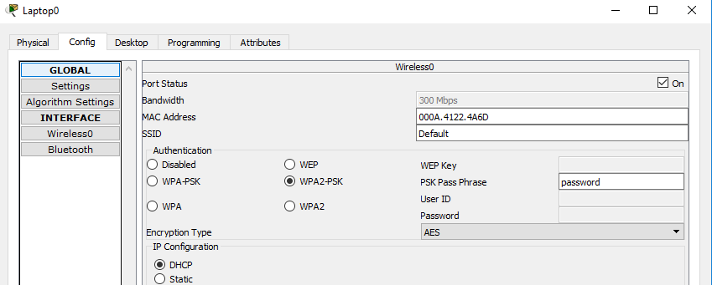

When all of your systems are online go to a system, open a web browser and open the web page for **server.com**



Now go back to your router and go into the basic wireless settings. Change the Network Name (SSID) of your router and turn off the SSID broadcast.

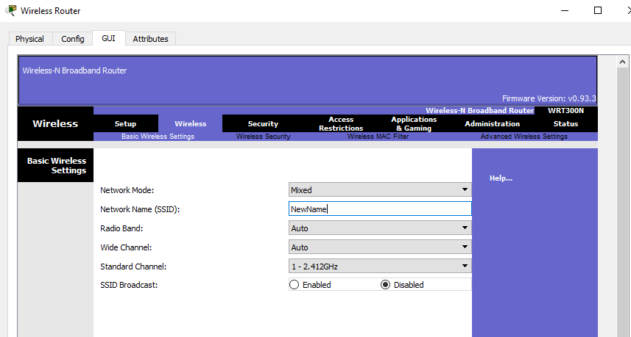

Go back to your systems on the desktop. What happened to your network?

Verify your network.

Turn off your laptop and the tablets and then turn it back on. What happened?

**Deliverables for Task 1**

Screenshot of your working network with all devices attached to the wireless system.

Answer question about DHCP

Answer question about wireless security

Answer question about change is security

Screenshot of web browser attached to InternetServer

Answer question about change in SSID

Answer question about turning of your devices.

**Task 2 – Installing a Firewall**

Your company has decided to install a firewall into the company network. They have heard they need a “DMZ” for their InternetServer and a second firewall connection between the DMZ and their network.



The firewall is located in Packet Tracer under routers

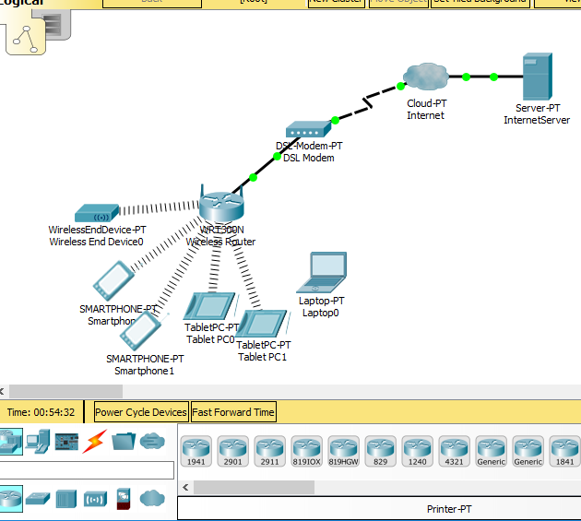

Drag and drop a firewall into the network and attach it as follows

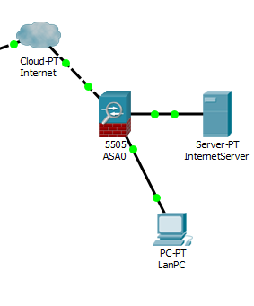

The connection to the Internet will be E0/0 (External LAN connection), InternetServer will be E0/2 (your DMZ connection) and your LanPC connected to E0/1 (Internal LAN connection).

Attempt to pull your web page from your InternetServer. What happened? Why?

What can you tell me about installing a firewall into a network that would help someone unfamiliar with the process?

**Deliverables for Task 2**

Screenshot of your network with firewall attached

Answer the question about the web page

Answer the question about installing a firewall